Jenkins Installation Document
Prepared by | Balaji.V.S

Indroduction about Jenkins
* Jenkins is Open source.
* Jenkins is Continuous Integration, process of deploying apps in Development/QA/Live environment.
* Continuous Integrations are as follows [Predefined Process Steps] :
- Checks for latest checkout/version in Source control like (SVN/CVS/GitHub etc.)
- Build war using build tools like (Appache ant / Maven etc.)
- Automated test done using Testing tools like (Junit etc.)
- Deploy them into Development/QA/Production environment.
[All these Predefined Steps for Continuous Integration are optional]
Installing Jekins
Step 1: Download jenkins war from http://jenkins-ci.org/

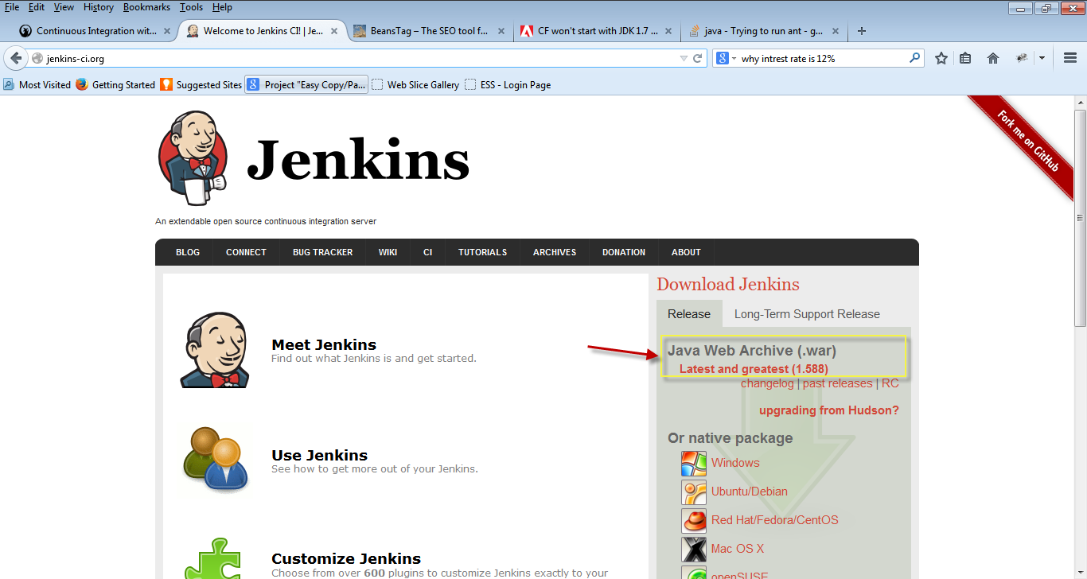

Step 2: Place Jenkins local directory or / inside Tomact webapps folder.
D:\Jenkins\jenkins.war

Step 3: Set Path and Classpath for JAVA
prompt:> set JAVA_HOME=D:\jdk1.7
prompt:> set path=d:\jdk1.7\bin
prompt:> set classpath=%classpath%;d:\jdk1.7\lib;.;
Step 4: 2 ways to start Jenkins application.
1. By directly in command prompt.
RUN->cmd-> Java -jar jenkins.war
2. By hosting jenkins.war file in webserver like Appache tomcat
D:\tomcat7.0\webapps\jenkins.war

Step 5: Type the following. it will open jenkin console.
* http:/localhost:8080/ [opens jenkins console like below]

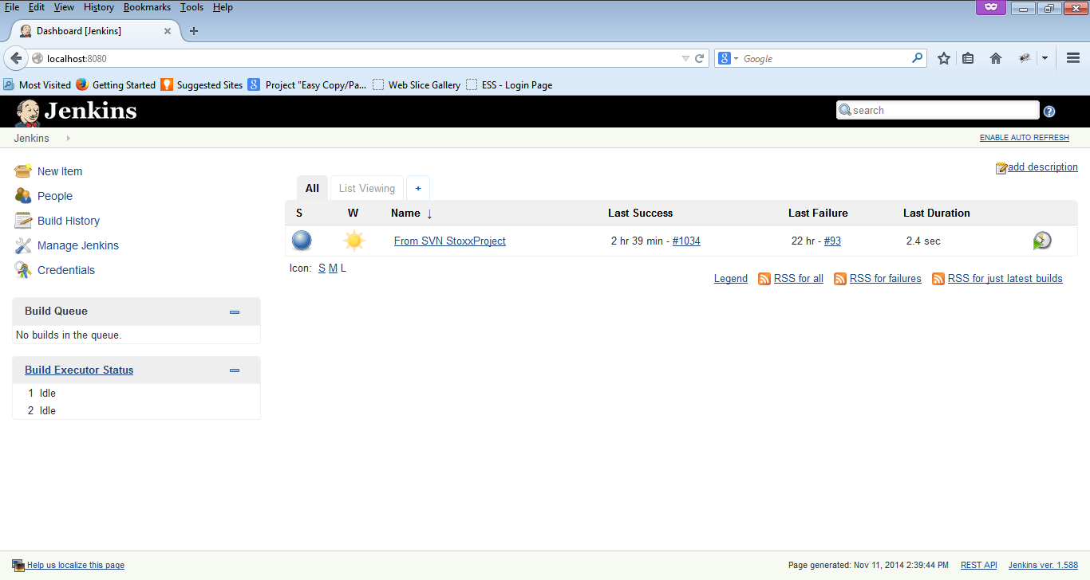

Step 6: On clicking Manage Jenkins Install all your plugins that you needed.
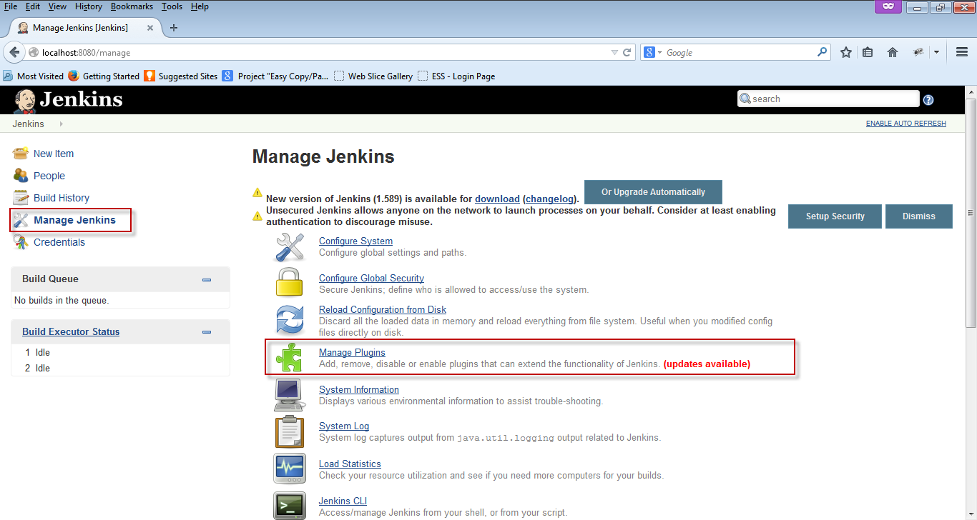

Step 7: Basic plugins that you needed are
* SVN or CVS or GITHUB etc. [This Source control plugins depands on Project developement]
* Appache ANT or Maven etc. [This Build tools plugins depands on platform JAVA or .Net etc.]
* Mailer plugins for Success or Failure Notifications.

Step 8: On clicking Mange Plugins you get list of plugins displayed.
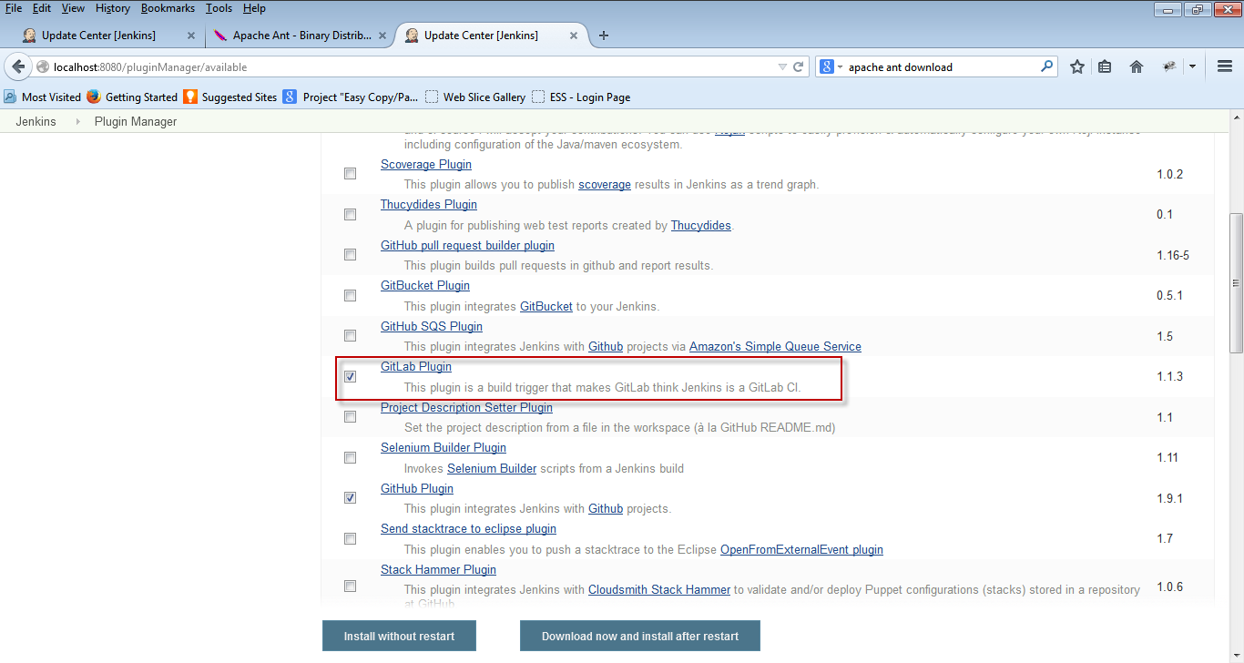

Step 9: On installing will look this below screen. it will take some time to complete.
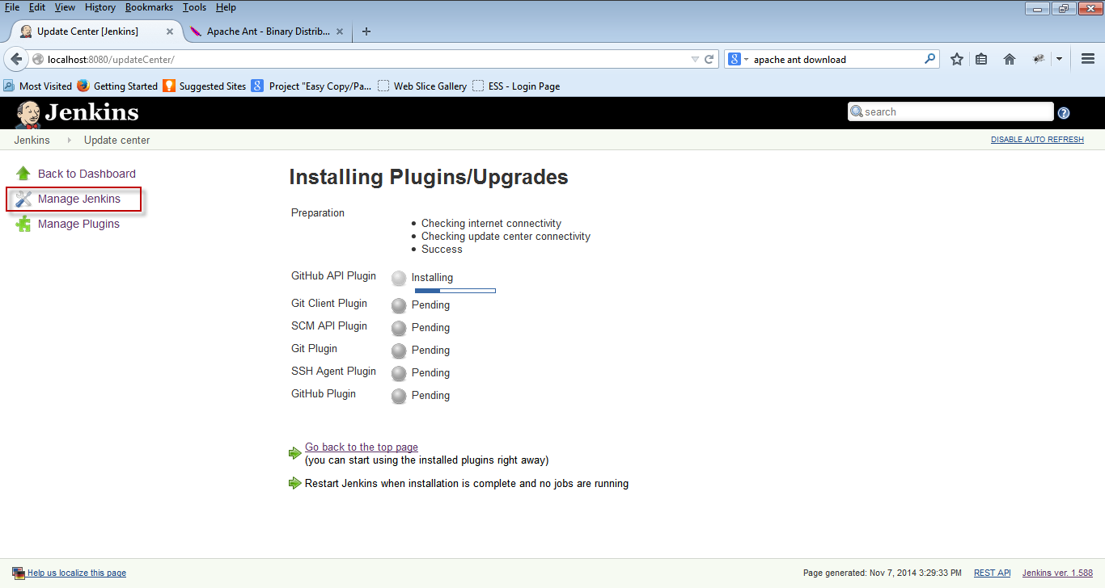

Step 10: After Successfull installation of basic plugins.
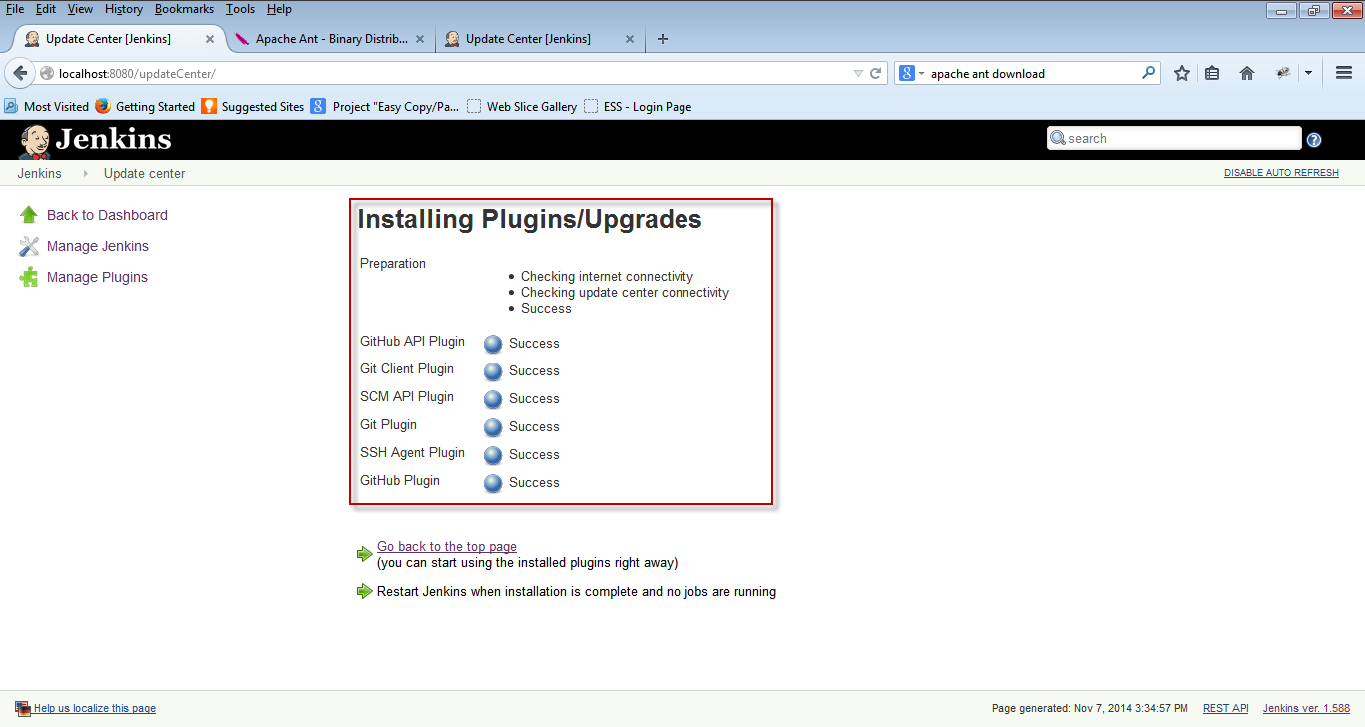
Step 11: Configure Jenkins
From the console select Manage Jenkins -> Configure System
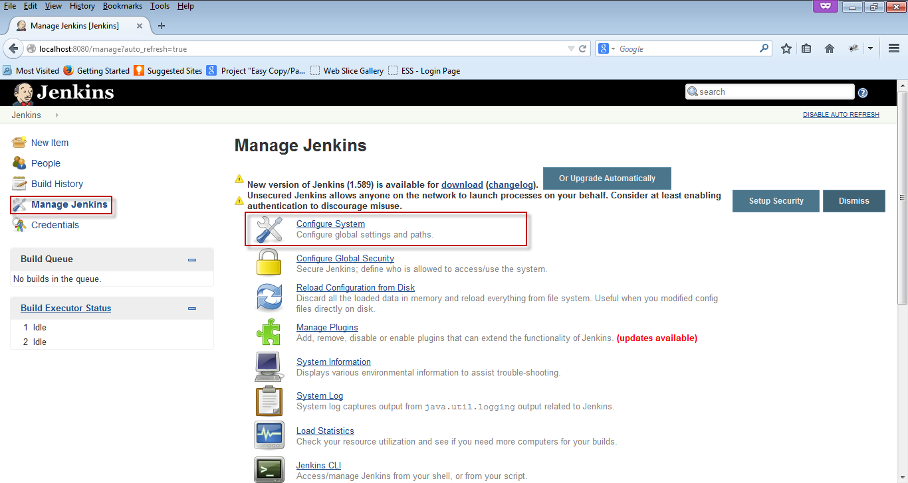

Step 11.1: Configuration screen
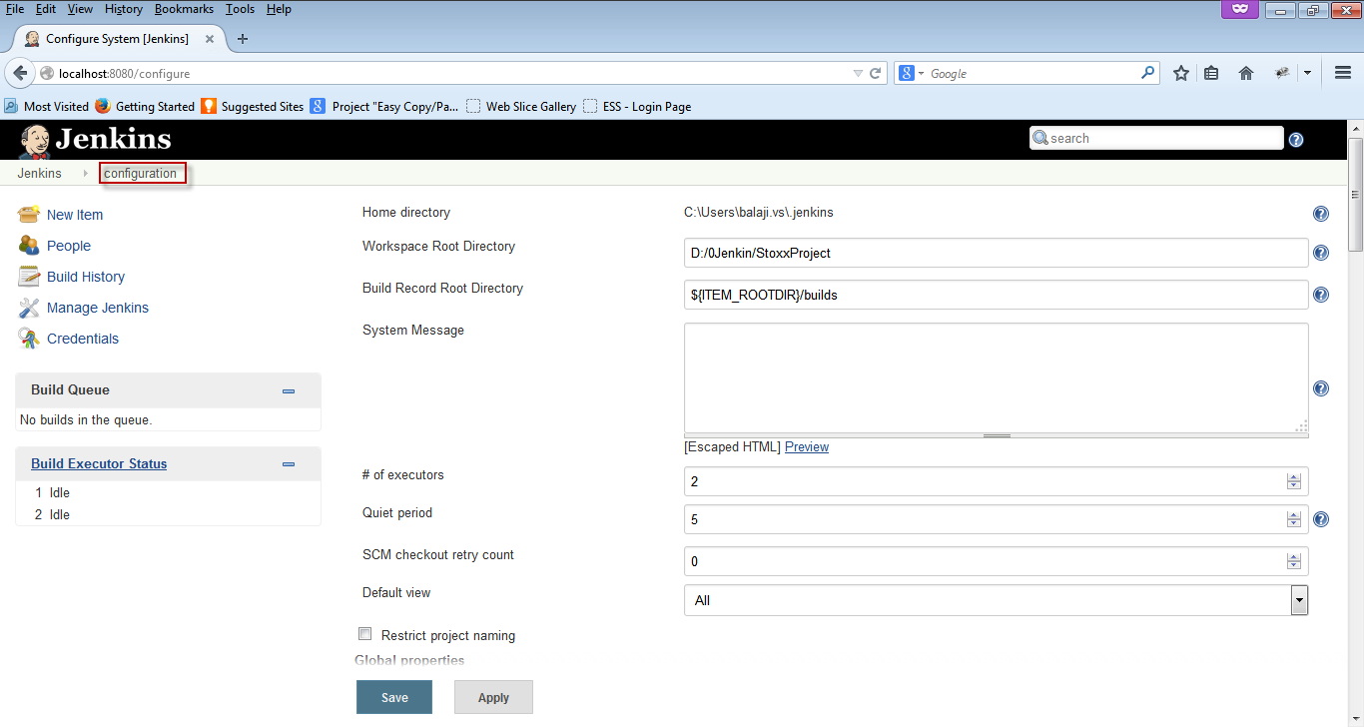
Step 11.1.a: Set Workspace Root Directory for Jenkins. [local directory]
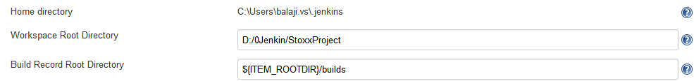
Step 11.1.b: Confiruring JAVA_HOME
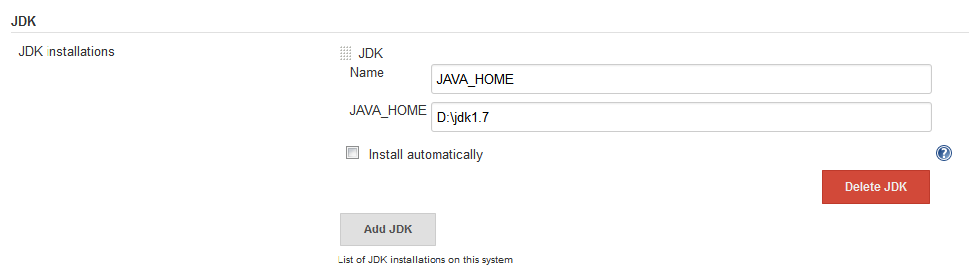

Step 11.1.c Confiruring Ant source control.
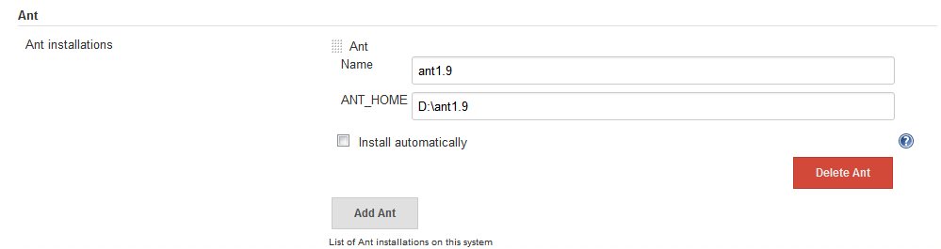
Step 11.1.d: customize your jenkins URL and jenkins admin mail id.
* This configuration send success or failure build notification mail from jenkins admin mail id.
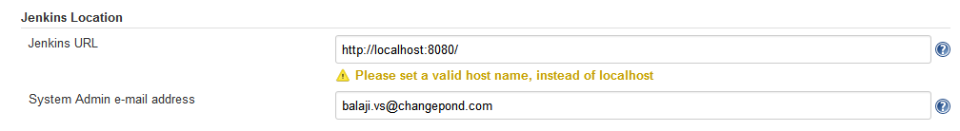
Step 11.1.e: Mail server configuration
* specify your mail server ip address.
* specify you domain configuration.
* [optional] mail can be tested.
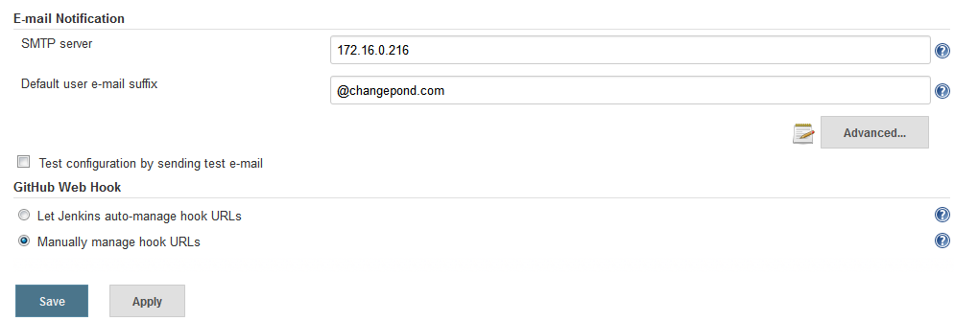
Step 12: Click Apply and Save button. [Now Jenkins is ready for project configuration.]

